# Agile interview questions:

Who to talk to?

1. Bhasker
2. Sunil
3. Madhan

Pending Topic to prepare?

Agile metrics and Maturity levels

SAFe or Enterprise Scaled Agile

Basics:

**Roles in**[**Scrum**](https://www.softwaretestinghelp.com/agile-scrum-methodology-for-development-and-testing/)

1. **Project Owner** has the responsibility of managing the product backlog. Works with end-users and customers and provides proper requirements to the team to build the proper product.
2. **Scrum Master**works with the scrum team to make sure each sprint gets completed on time. Scrum master ensures proper workflow for the team.
3. **Scrum Team:** Each member of the team should be self-organized, dedicated and responsible for the high quality of the work.

**What is the difference between Epic, User stories & Tasks?**

**Epic:** A group of related user stories is called an Epic.

**User Stories:**It defines the actual business requirement. Generally created by the business owner.

1. Business User Story
2. Spike (Research) User Story
3. Technical User Story
4. Cross reference Story (Between Scrum Team)
5. Bug User Story

**Task:**To accomplish the business requirements development team create tasks.

**Product Backlog & Sprint Backlog?**

The **Product backlog** is maintained by the project owner which contains every feature and requirement of the product.

**Sprint backlog**  - Spring Ready user stories

Concept of parking lot backlog and user stories.

**Velocity in Agile**

**Answer:** Velocity is a metric that is calculated by the addition of all efforts estimates associated with user stories completed in an iteration.

**How do you deal when requirements change frequently?**

1. Work with Product Owner to understand the exact requirement
2. understand the risk of changing the requirement

**Difference between burn-up and burn-down charts? What is the use?**

**Answer:** Burn-up and burn-down charts are used to keep track of the progress of the project.

Burn-up charts represent how much work has been completed in any project whereas Burn-down chart represents the remaining work in a project.

**Q #20) What is Spike?**

**Answer:** There may be some technical issues or design problem in the project which needs to be resolved first. To provide the solution to this problem “Spikes” are created.

**Spikes are of two types-** Functional and Technical.

Agile Metrics: and How to calculate it?

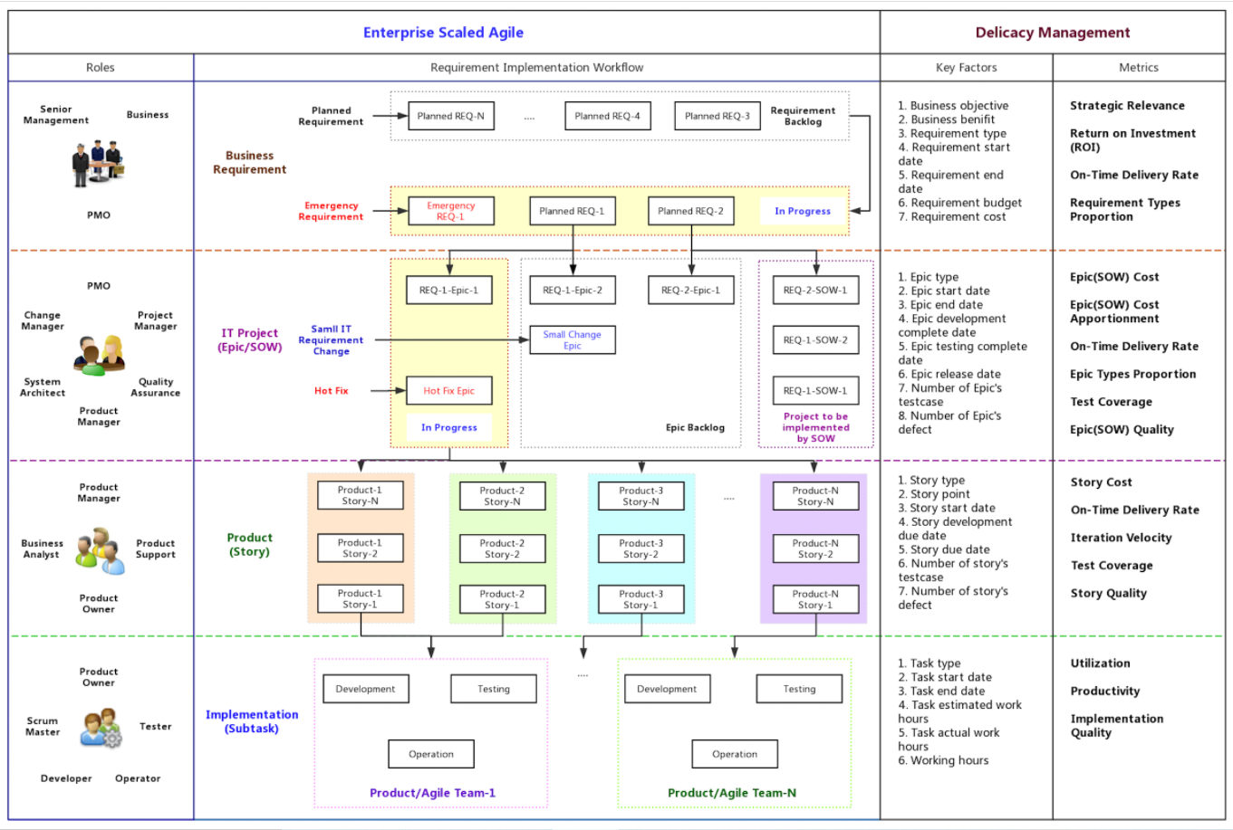

Utilization , Productivity:

* Team’s Available Velocity vs iteration velocity

Implementation Quality:

* Count number of Bug user stories

Story Quality: INVEST

* A good user story should be:
* “I” ndependent (of all others)
* “N” egotiable (not a specific contract for features)
* “V” aluable (or [vertical](http://guide.agilealliance.org/guide/incremental.html))
* “E” stimable (to a good approximation)
* “S” mall (so as to fit within an iteration)
* “T” estable (in principle, even if there isn’t a test for it yet)

On-Time Delivery Rate:

Considerations:

* Number of Spikes
* Number of User Story slips

Iteration velocity:

* Number of story points scrum team is delivering.

**Explain Pair Programming and its benefits?**

**Answer:** Pair programming is a technique in which two programmer works as a team in which one programmer writes code and other one reviews that code. They both can switch their roles.

**Benefits:**

* **Improved code quality:** As the second partner reviews the code simultaneously, it reduces the chances of mistake.
* **Knowledge transfer is easy:** One experienced partner can teach another partner about the techniques and codes.

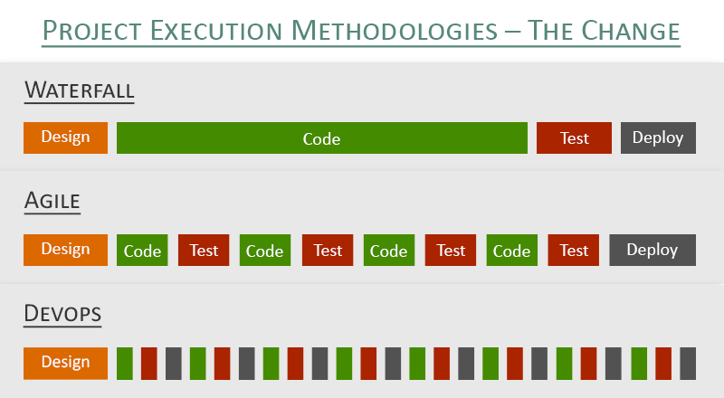

References:

<https://www.softwaretestinghelp.com/25-best-agile-testing-interview-questions-and-answers/>

<https://community.atlassian.com/t5/image/serverpage/image-id/55701iBBACD36AE15AE69D?v=1.0>